**Arthritis may NOT be due to 'wear and tear': High-fibre diets reduce your risk of developing the condition by up to 61%**

* This is comparing those who have the highest daily fibre intake to the lowest
* High-fibre intakes also appear to prevent existing knee pain from getting worse
* Fibre is found in high amounts in brown rice, potato skins and other vegetables
* Arthritis UK warn more research is needed to assess high-fibre diets' benefits

By [Alexandra Thompson Health Reporter For Mailonline](http://www.dailymail.co.uk/home/search.html?s=&authornamef=Alexandra+Thompson+Health+Reporter+For+Mailonline)

**PUBLISHED:** 12:55, 25 May 2017 | **UPDATED:** 02:16, 26 May 2017

* [e-mail](mailto:?subject=Read%20this:%20Arthritis%20may%20NOT%20be%20due%20to%20%27wear%20and%20tear%27:%20High-fibre%20diets%20reduce%20your%20risk%20of%20developing%20the%20condition%20by%20up%20to%2061%25&body=Arthritis%20may%20NOT%20be%20due%20to%20%27wear%20and%20tear%27%3A%20High-fibre%20diets%20reduce%20your%20risk%20of%20developing%20the%20condition%20by%20up%20to%2061%25%0A%0AResearchers%20from%20Tuft%20University%2C%20Boston%20and%20the%20University%20of%20Manchester%20compared%20those%20with%20the%20highest%20daily%20fibre%20intake%20to%20those%20consuming%20the%20lowest%20amounts.%0A%0Ahttp%3A%2F%2Fwww.dailymail.co.uk%2Fhealth%2Farticle-4541004%2FFibre-reduces-risk-arthritis-61.html%3Fito%3Demail_share_article-top%0A%0A%0AMost%20Read%20Articles%3A%0A%0ARevealed%3A%20What%20it%27s%20like%20to%20get%20vitamin%20injections%20-%20and%20do%20you%20really%20feel%20amazing%20after%3F%C2%A0%0Ahttp%3A%2F%2Fwww.dailymail.co.uk%2Fhealth%2Farticle-4645022%2FWhat-s-like-vitamin-injections.html%3Fito%3Demail_share_article-top_most-read-articles%0A%0AMother%20who%20gave%20birth%20to%20stillborn%20son%20after%20vomiting%20blood%20learns%20she%20has%20stage%204%20cancer%20which%20killed%20her%20child%0Ahttp%3A%2F%2Fwww.dailymail.co.uk%2Fhealth%2Farticle-4641536%2FMother-stillborn-learns-stage-4-cancer.html%3Fito%3Demail_share_article-top_most-read-articles%0A%0AWoman%2C%2020%2C%20bullied%20and%20branded%20%27a%20chocolate%20chip%20cookie%27%20because%20of%20her%20head-to-toe%20hairy%20moles%20could%20be%20crowned%20the%20next%20Miss%20Universe%21%0Ahttp%3A%2F%2Fwww.dailymail.co.uk%2Fhealth%2Farticle-4646194%2FWoman-covered-hairy-moles-auditions-Miss-Universe.html%3Fito%3Demail_share_article-top_most-read-articles%0A%0A)

**154**shares

**[120](http://www.dailymail.co.uk/health/article-4541004/Fibre-reduces-risk-arthritis-61.html" \l "comments)**

[View comments](http://www.dailymail.co.uk/health/article-4541004/Fibre-reduces-risk-arthritis-61.html" \l "comments)

High-fibre diets significantly reduce the risk of developing arthritis, according to new research.

Those with the greatest fibre intake are up to 61 per cent less likely to develop the condition than those consuming the lowest amounts, a review of two studies found.

Eating lots of fibre, found in brown rice, potato skins and other vegetables, may also prevent existing knee pain from worsening, the researchers said.

These findings may debunk the theory that arthritis occurs due to 'wear and tear' as damaged cartilage is unable to properly repair itself.

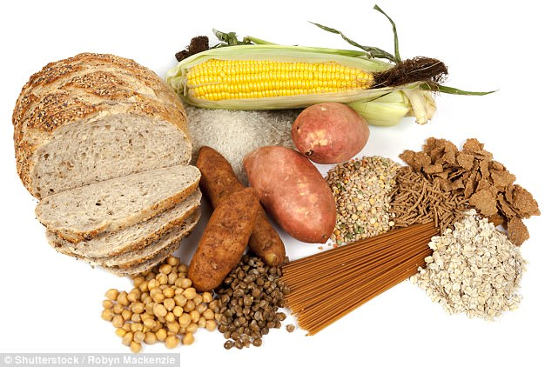

+2

High-fibre diets significantly reduce the risk of developing arthritis in the knee, study shows

**RELATED ARTICLES**

* [Previous](http://www.dailymail.co.uk/health/article-4541004/Fibre-reduces-risk-arthritis-61.html)
* [1](http://www.dailymail.co.uk/health/article-4541004/Fibre-reduces-risk-arthritis-61.html)
* [Next](http://www.dailymail.co.uk/health/article-4541004/Fibre-reduces-risk-arthritis-61.html)
* [**[](http://www.dailymail.co.uk/news/article-4539914/How-stop-teenagers-drinking-smoking.html)How can you stop teenagers from drinking and smoking? Just...**](http://www.dailymail.co.uk/news/article-4539914/How-stop-teenagers-drinking-smoking.html)[**[](http://www.dailymail.co.uk/news/article-4539850/Health-risk-sleeping-six-hours.html)Health risk of sleeping for less than six hours: Study says...**](http://www.dailymail.co.uk/news/article-4539850/Health-risk-sleeping-six-hours.html)[**[](http://www.dailymail.co.uk/health/article-4539550/Is-marijuana-factor-jihadi-murders.html)Potheads: DR MAX PEMBERTON asks if marijuana is a factor in...**](http://www.dailymail.co.uk/health/article-4539550/Is-marijuana-factor-jihadi-murders.html)[**[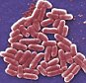](http://www.dailymail.co.uk/health/article-4539132/UN-joins-war-against-sepsis-call-global-action.html)Now UN joins the war against sepsis with a call for global...**](http://www.dailymail.co.uk/health/article-4539132/UN-joins-war-against-sepsis-call-global-action.html)

**SHARE THIS ARTICLE**

Share

**154** shares

**IS KEYHOLE KNEE SURGERY FOR ARTHRITIS POINTLESS?**

Keyhole knee operations on patients with a common form of arthritis should stop as they do little to help, according to a review in the British Medical Journal earlier this year.

Arthroscopic surgery – a minor procedure to treat arthritic knees and torn cartilage – has been 'oversold as a cure-all for knee pain', the report says.

Professor Mark Wilkinson, for Arthritis Research UK, said: 'Previous studies have shown that knee arthroscopy is not recommended for the symptoms of pain and loss of function for people with degenerative knee arthritis.

'They will benefit from lifestyle modification, exercise, physiotherapy, pain medication or joint replacement.'

Researchers from Tuft University, Boston and the University of Manchester conducted a review of two studies.

These included the Osteoarthritis Initiative (OAI) trial, which had 4,796 participants and the Framingham Offspring Osteoarthritis Study, which comprised 1,268 people.

The researchers determined the participants' fibre intake at the beginning of the study via a questionnaire, as well as collecting data on any knee injuries, medication, alcohol intake and physical activity.

They also used X-rays to determine whether the participants had OA symptoms; namely knee stiffness, swelling and pain.

OA is the most common form of arthritis.

The OAI study followed its participants every 12 months for four years and found they consumed an average of 15 grams of fibre a day.

While the Framingham trial evaluated its respondents, who ate around 19 grams of fibre a day, after nine years.

Results, published in the Annals of the Rheumatic Diseases, revealed that in the OAI study, 869 knees had OA symptoms and 152 showed signs of the disease on an X-ray.

Pain worsened in 1,964 knees, the results revealed.

In the Framingham study, 143 knees showed symptoms and 175 revealed signs of OA on an X-ray.

Participants from both studies were divided into four groups according to their daily fibre intake.

Those in the highest intake group had a 30 per cent lower risk of OA in the OAI study and a 61 per cent reduced susceptibility in the Framingham study, compared to those who ate the least amount of fibre.

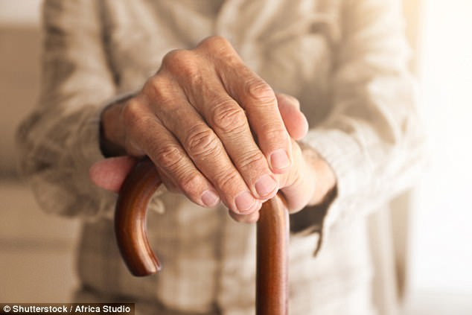

+2

Consuming high amounts of fibre also appears to reduce the risk of arthritis pain worsening

The findings also showed that consuming more fibre, particularly from cereals, reduced the risk of knee pain worsening.

Dr Natalie Carter, head of research liaison and evaluation at Arthritis Research UK, told MailOnline: 'This research is very interesting and expands our understanding of the link between diet and arthritis.

'However, further research is needed to fully assess the potential benefits of a high-fibre diet.

'If you have OA, the most important thing for you to do is have a healthy balanced diet, maintain a healthy weight and remain active.'

This comes after researchers from the University of Surrey found a good diet and regular exercise can prevent arthritis.

Eating poorly and being inactive reprogrammes cells in the joints, leading to an overproduction of glucose that causes inflammation and immobility, they found.

Read more: <http://www.dailymail.co.uk/health/article-4541004/Fibre-reduces-risk-arthritis-61.html#ixzz4lIml58yG>   
Follow us: [@MailOnline on Twitter](http://ec.tynt.com/b/rw?id=bBOTTqvd0r3Pooab7jrHcU&u=MailOnline) | [DailyMail on Facebook](http://ec.tynt.com/b/rf?id=bBOTTqvd0r3Pooab7jrHcU&u=DailyMail" \t "_blank)